Ticketing System – Complete Documentation
Version 1.0 | December 29, 2025

Project Overview
A modern, role-based Helpdesk / Ticketing System built with Laravel 12 that allows customers to submit support tickets, agents to manage assigned tickets, and administrators to oversee everything.
Key Features:
- Customer ticket submission with image attachments
- Threaded comments & replies
- Feedback rating & ticket reopening
- Role-based access (Customer, Agent, Admin)
- Admin & Agent dashboards
- Soft delete & active/inactive toggle
- Privacy Policy & Terms of Service pages

User Guide (For End Users)

1. Getting Started
- Open the application in your browser
- Register a new account or Login with existing credentials
- You will be redirected based on your role:
  - Customer → My Tickets
  - Agent → Agent Dashboard
  - Admin → Admin Panel

2. Customer Features

Create a New Ticket
- Click "New Ticket"
- Fill in:
  - Title
  - Category
  - Priority (Low/Medium/High)
  - Detailed description
  - Attach images (optional, multiple allowed)
- Click Submit Ticket

My Tickets List
- View all your submitted tickets
- See ticket ID, title, category, priority, status, rating, and last update
- Click View to open details

Ticket Details
- View full description and attached images
- See complete conversation thread
- Reply to support team
- When ticket is Resolved or Closed:
  - Submit feedback rating (Excellent → Poor)
  - Add optional comment
  - If not satisfied → click "Reopen Ticket" (can be done multiple times)

Mobile Experience
- Works perfectly on Android & iOS browsers
- Add to home screen for native app-like experience (PWA)

Agent Guide

Agent Dashboard
- Shows only tickets assigned to you
- Stats: Total assigned, Open/In-progress, Resolved
- List of recent assigned tickets

Managing Tickets
- View full ticket details
- Reply to customer
- Update Status (Open → In Progress → Resolved → Closed)
- Update Priority
- All actions logged in conversation history

Admin Guide

Admin Panel
Accessible via sidebar → Admin Panel

Dashboard
- Overview of all tickets (total, open, resolved, closed)
- Recent activity across all users

All Tickets
- View every ticket in the system
- Advanced search & filters (status, priority, category, user)
- View, reply, assign, update status

User Management
- Create new users
- Edit user details and assign roles (Customer / Agent / Admin)
- Delete users (except self)

Category Management
- Create, edit, delete categories
- Toggle Active/Inactive (inactive categories hidden from customers)

Technical Documentation (For Developers)

Tech Stack
- Backend: Laravel 12 (PHP 8.2+)
- Database: MySQL
- Frontend: Bootstrap 5, Blade templates
- Authentication: Laravel Breeze
- File Storage: Laravel Filesystem (public disk)
- Responsive Design: Mobile-first Bootstrap + PWA ready

Database Schema
Table | Important Columns
users | id, name, email, password, role (customer/agent/admin), timestamps
categories | id, name, description, is_active, timestamps
tickets | id, user_id, category_id, title, description, priority, status, images (JSON), rating, feedback_comment, is_reopened, reopened_at, assigned_to, is_active, deleted_at (soft delete)
comments | id, ticket_id, user_id, parent_id (for replies), content, timestamps

Key Relationships
- Ticket → belongsTo User (creator)
- Ticket → belongsTo User (assigned_to as agent)
- Ticket → belongsTo Category
- Ticket → hasMany Comment
- Comment → belongsTo User
- Comment → belongsTo Comment (parent for replies)

Test Accounts
Role | Email | Password
Customer | zain@example.com | 11223344
Customer | sarah@example.com | password123
Agent | emma@support.com | password123
Agent | zain@support.com | 11223344
Admin | admin@example.com | password123

Future Enhancements (Optional)
- Email notifications on replies/assignment
- Real-time updates (Laravel Reverb / Pusher)
- Export tickets to PDF/CSV
- Advanced reporting & charts
- Dark mode toggle
- Mobile push notifications
Screenshots

1. Login Page
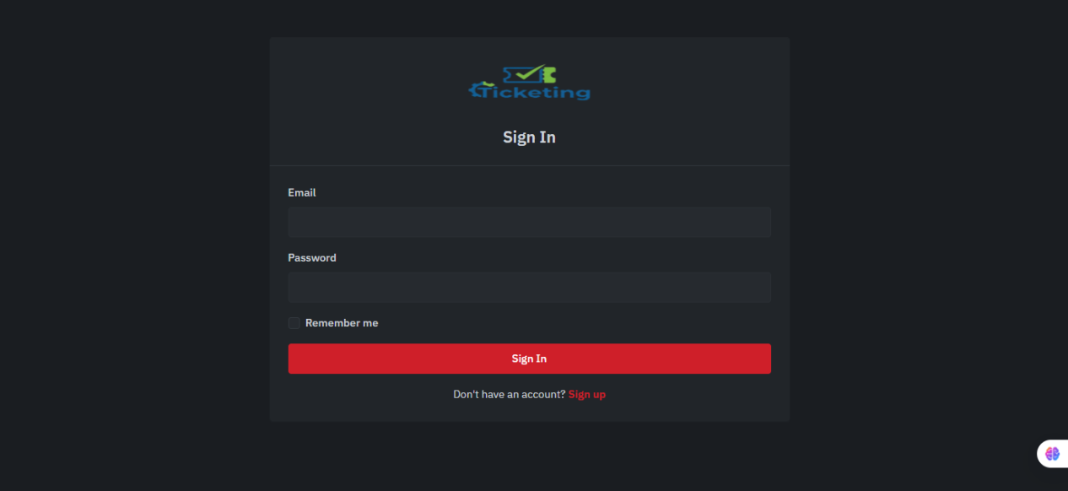
Caption: Clean, centered login form with email and password fields. Mobile-friendly design.

2. Registration / Sign Up Page
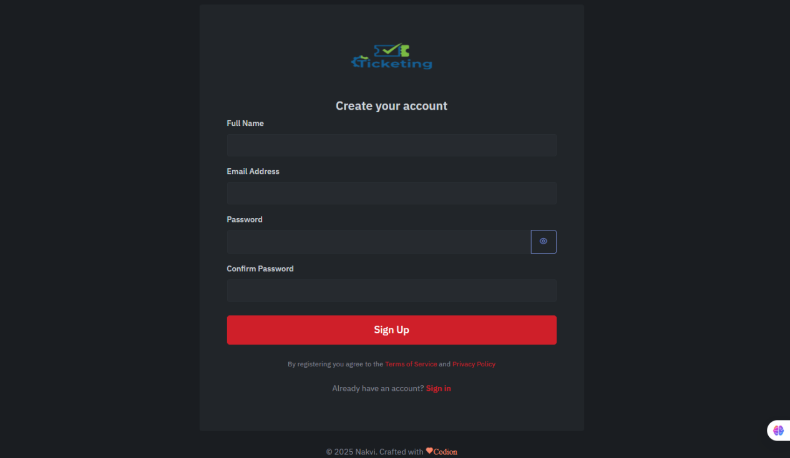
Caption: User registration with name, email, password, and role selection (for admin creation). Includes password visibility toggle.

3. Customer Dashboard – My Tickets
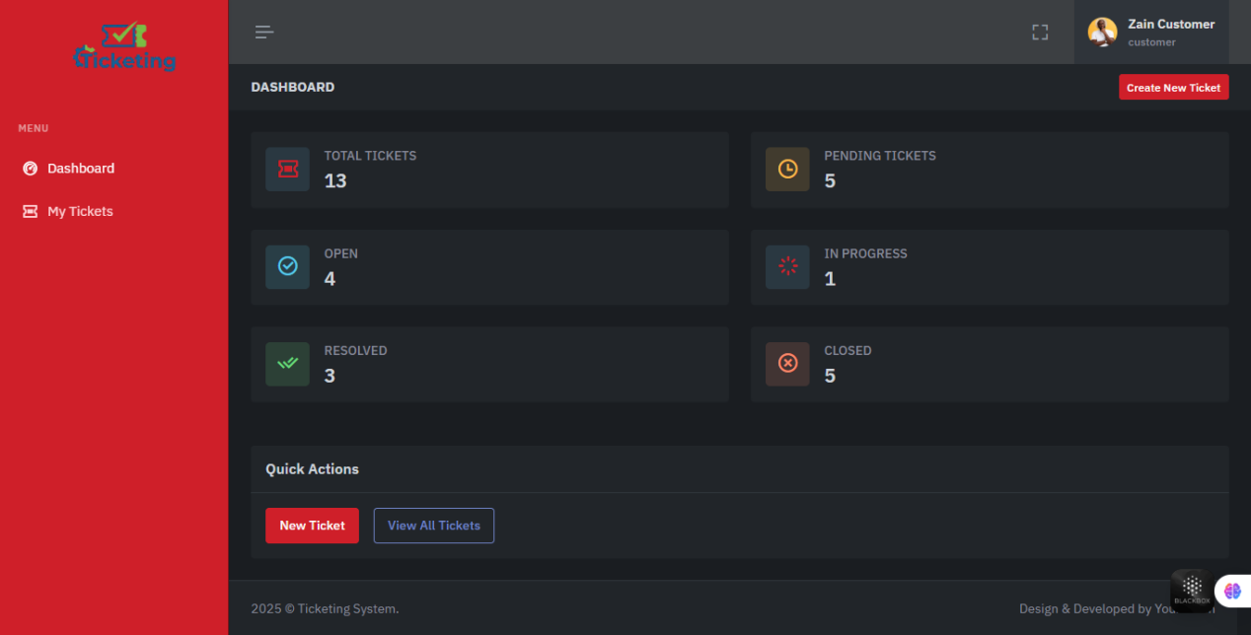
Caption: Customer view showing only their tickets with ID, title, category, priority, status, rating, and last updated time. "New Ticket" button prominent.

4. Create New Ticket (Customer)
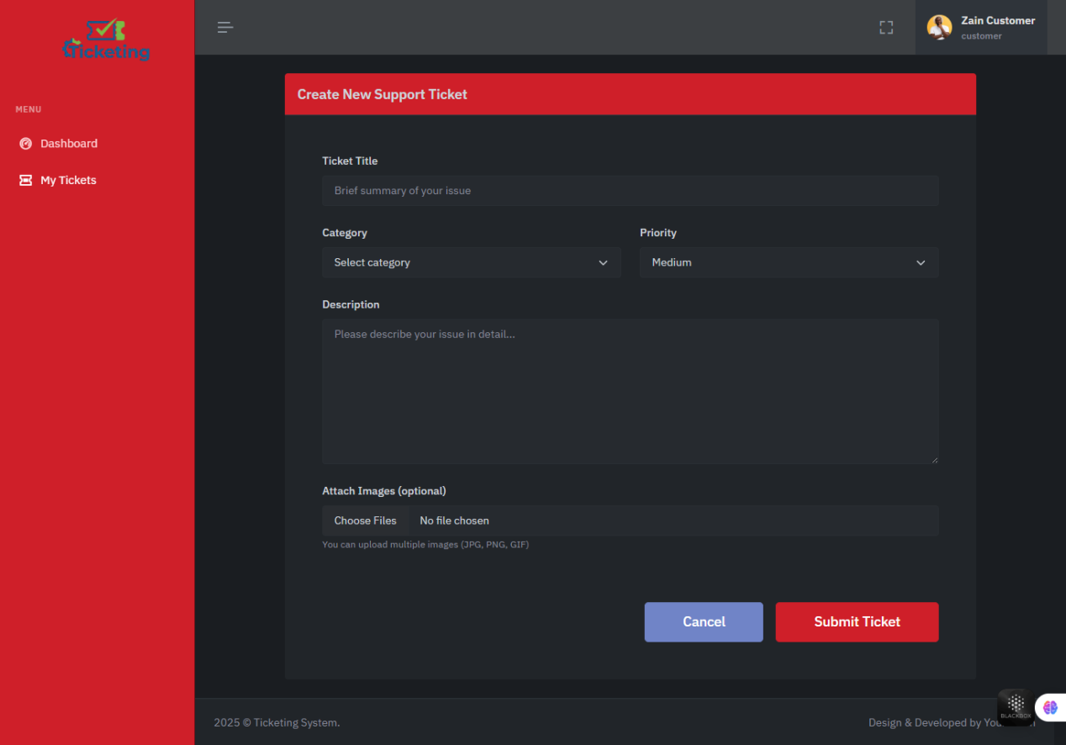
Caption: Form with title, category, priority, description, and multiple image upload with live preview.

5. Ticket Details (Customer View)
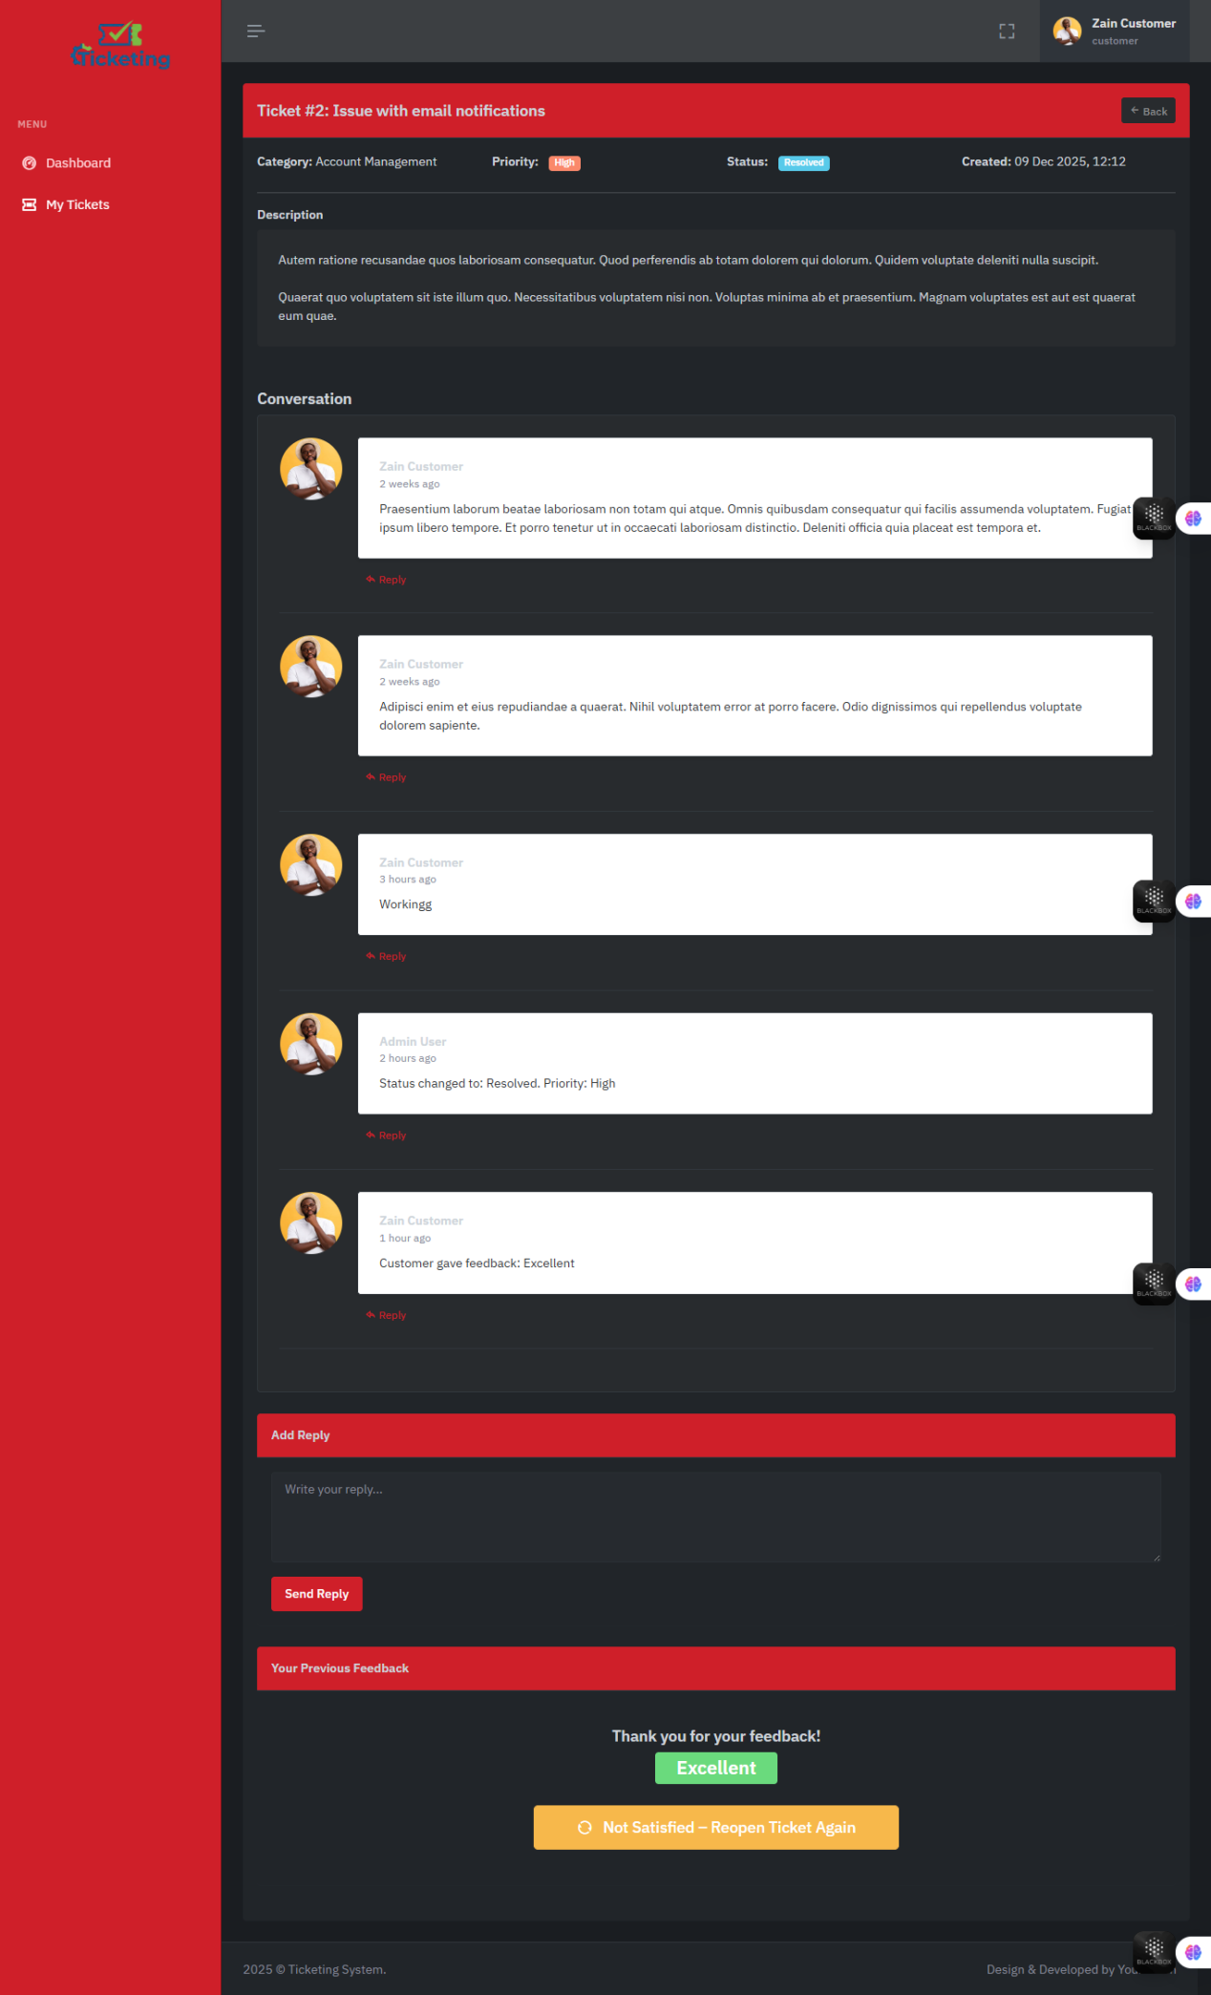Caption: Full ticket view with description, attached images, threaded conversation, reply form, feedback rating, and "Reopen Ticket" button.

6. Agent Dashboard
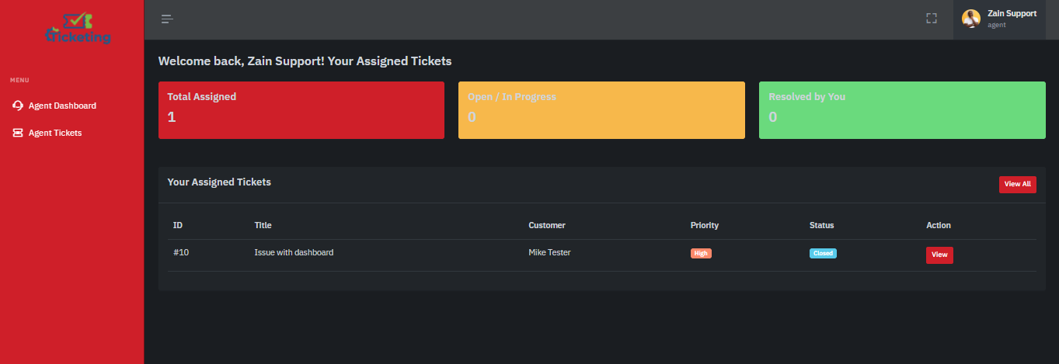
Caption: Agent sees only assigned tickets with personal stats: total assigned, open, resolved.

7. Agent – Assigned Tickets List
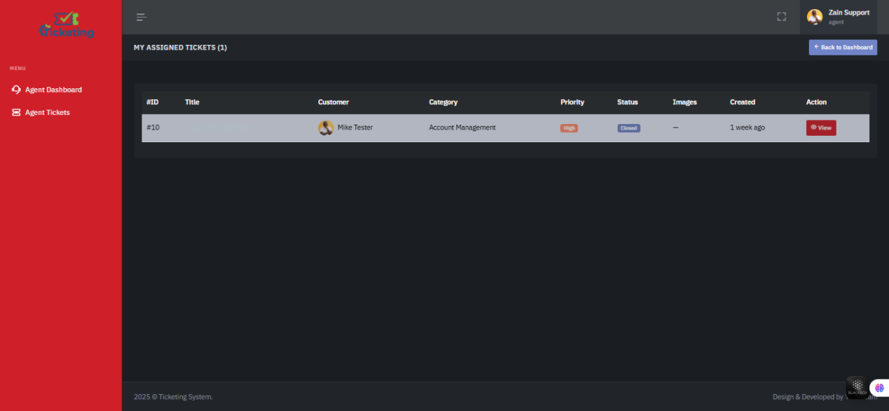
Caption: Clean list of tickets assigned to the agent with customer info, priority, status, and view button.

8. Agent – Ticket Details & Reply
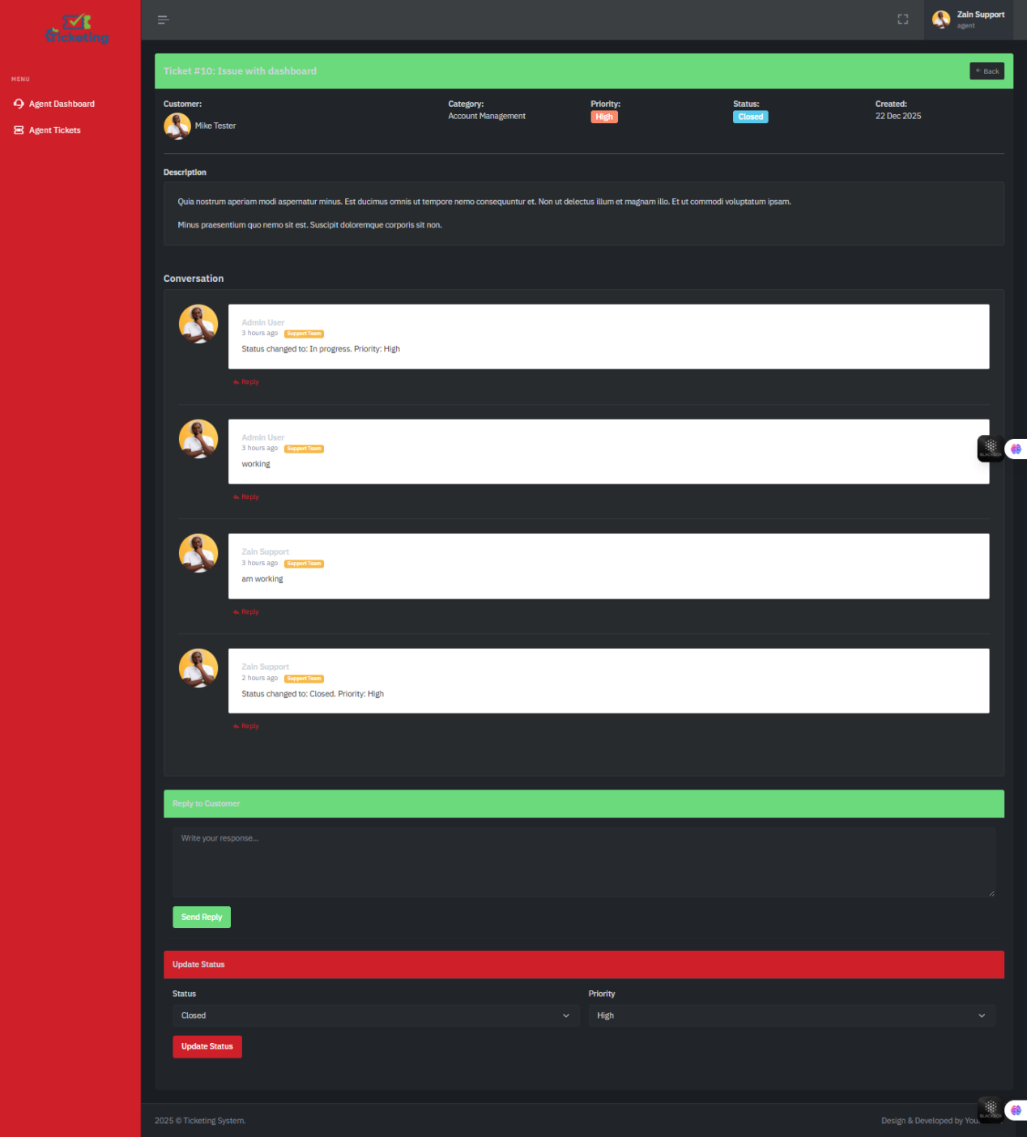
Caption: Agent can reply, update status/priority, and see full conversation. Support replies highlighted.

9. Admin Dashboard
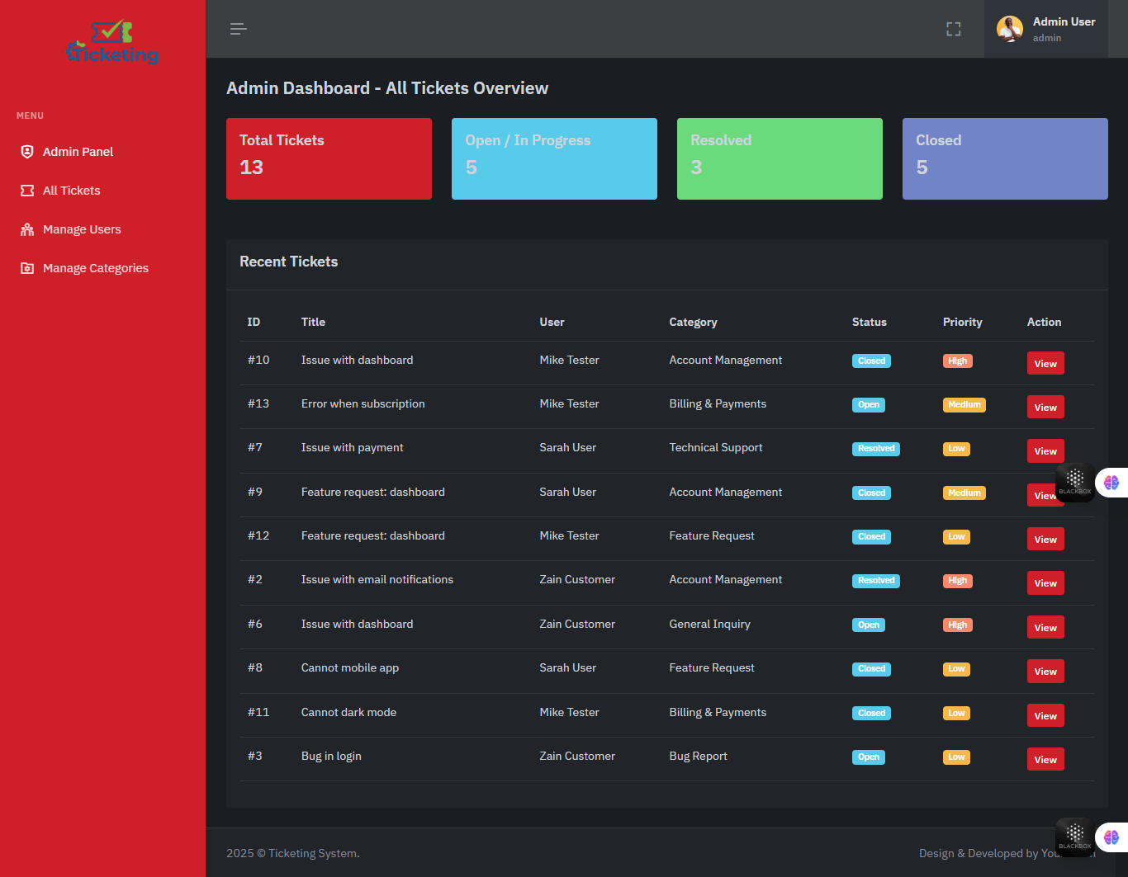
Caption: Global overview: total tickets, open, resolved, closed, and recent activity across all users.

10. Admin – All Tickets
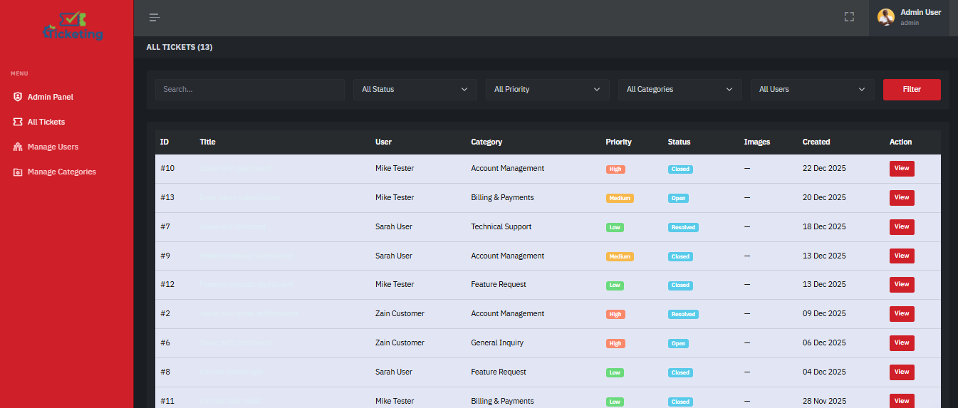
Caption: Full ticket list with advanced search and filters (status, priority, category, user). Shows trashed tickets.

11. Admin – Assign Ticket to Agent
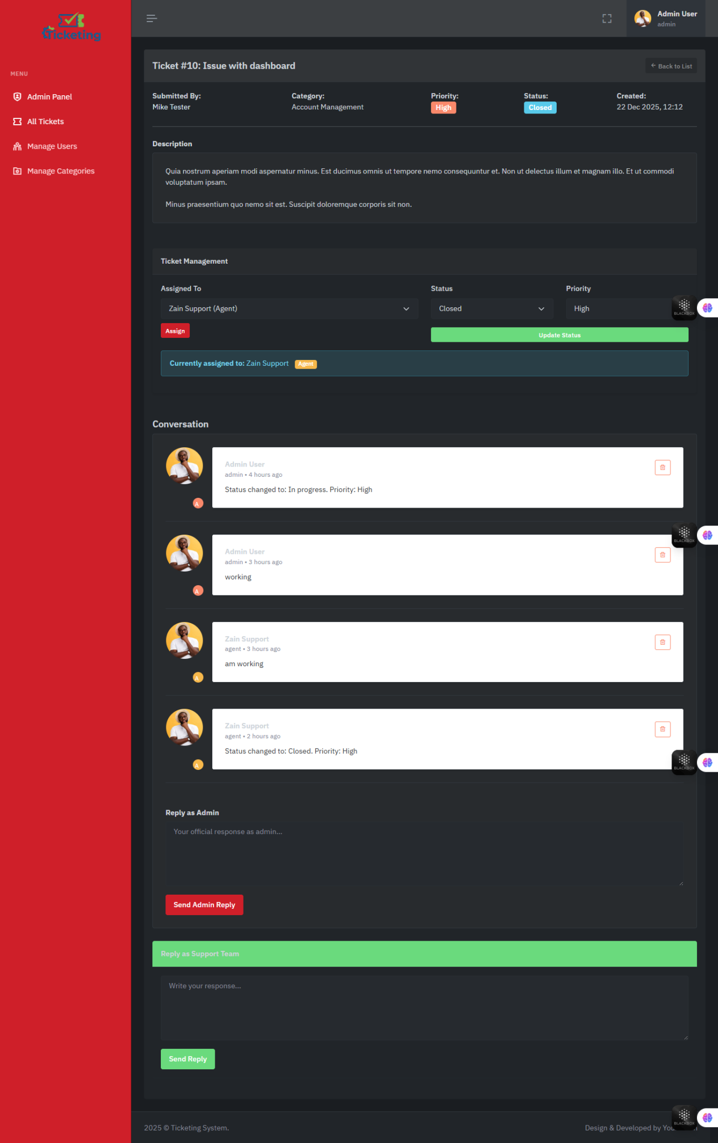
Caption: Admin can assign any ticket to any agent with dropdown and update status.

12. Admin – User Management
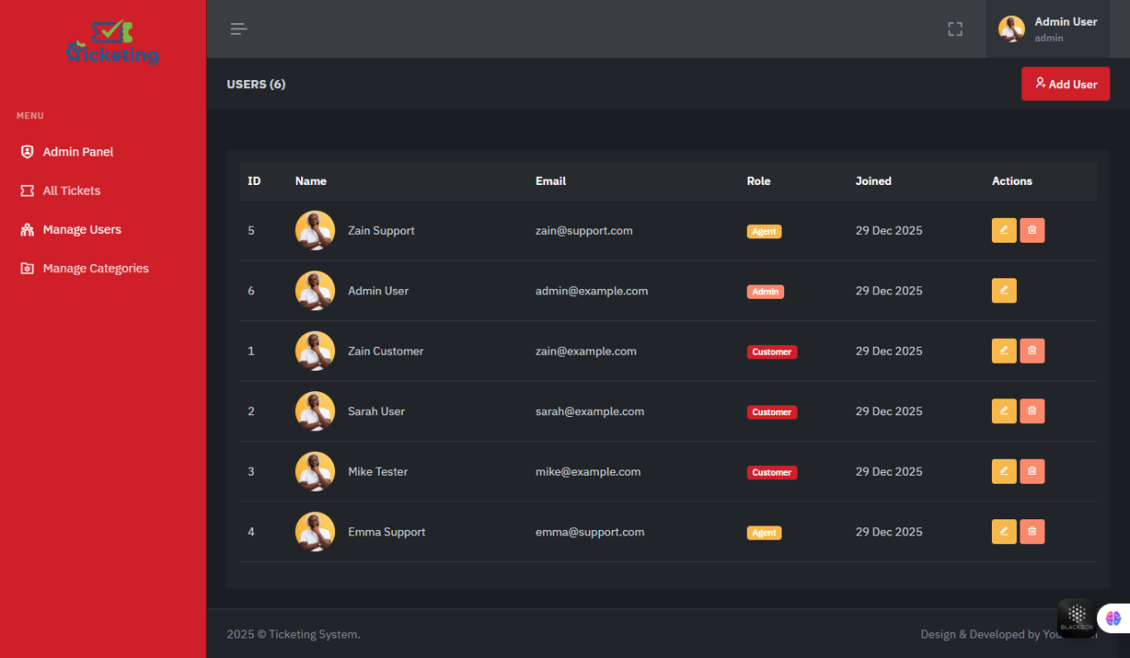
Caption: Create, edit, and delete users. Change roles (Customer → Agent → Admin).

End of Documentation

